Example: (Commutative Law using XOR)
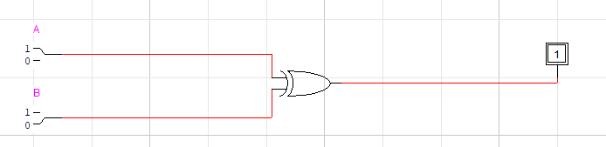
=
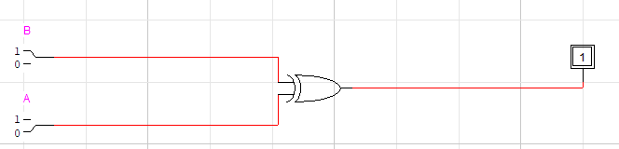
Expression:
a⊕b = b⊕a
A.B’ + B.A’ = B.A’ + A.B’

TASK 1:
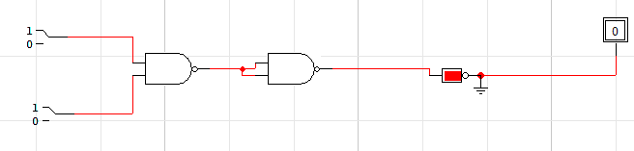
Expression:
F = ((A.B)’)’

TASK 2:
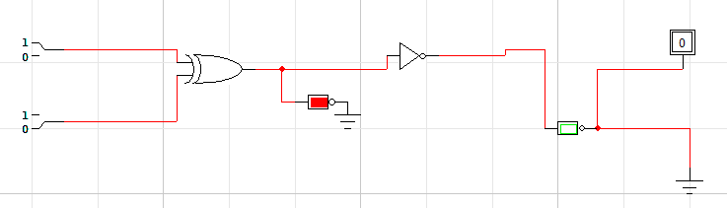
Expression:
F = (A⊕B)’

TASK 3 (Aircraft’s functional monitoring system):
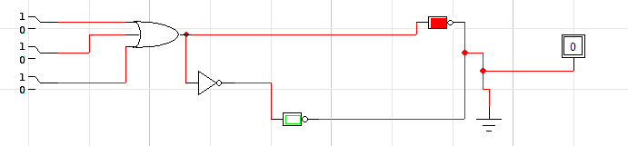
Expression:
F = (A+B+C)’
TASK 4:
Even Parity Generator (4bit data):
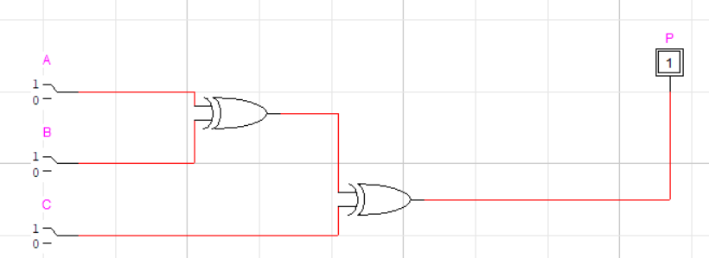

Odd Parity Generator (4 bit data):
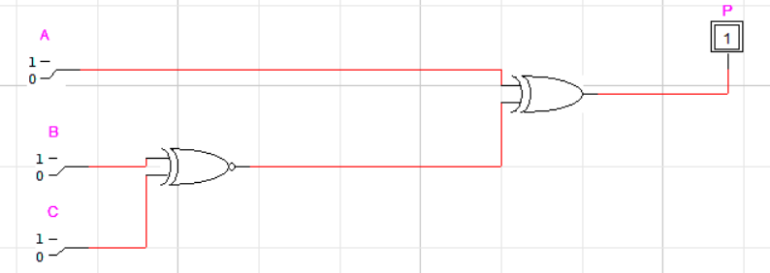
TASK 5 (Failure Detection Circuit):
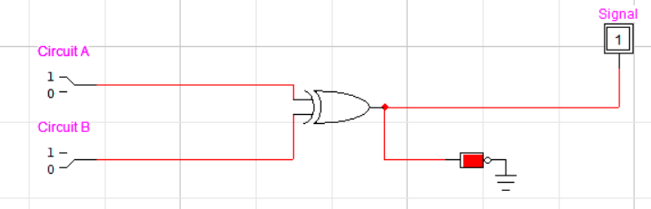
This circuit assumes that the failure mode where the outputs are at opposite levels is the only possible failure mode. If there are other failure modes that could result in the same output levels for both circuits, this circuit may not be sufficient for detecting those failures.
TASK 6:
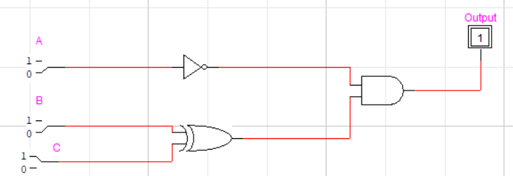
A | B | C | A’ | B⊕C | OUTPUT
0 | 0 | 0 | 1 | 0 | 0
0 | 0 | 1 | 1 | 1 | 1
0 | 1 | 0 | 1 | 1 | 1
0 | 1 | 1 | 1 | 0 | 0
1 | 0 | 0 | 0 | 0 | 0
1 | 0 | 1 | 0 | 1 | 0
1 | 1 | 0 | 0 | 1 | 0
1 | 1 | 1 | 0 | 0 | 0

TASK 7:
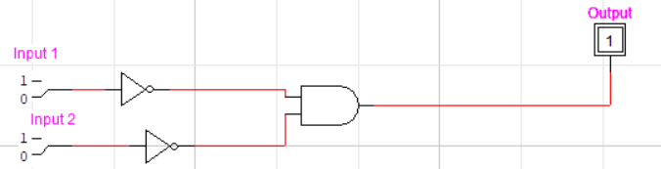
TASK 8:
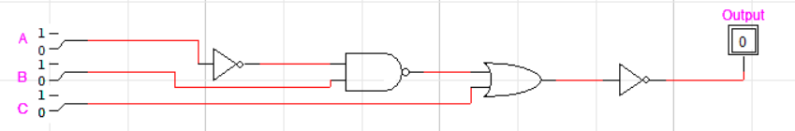
Boolean Expression:
F = ((A’.B)+C)’

A | B | C | A’.B | (A’.B)+C | OUTPUT
0 | 0 | 0 | 0 | 0 | 1
0 | 0 | 1 | 0 | 1 | 0
0 | 1 | 0 | 1 | 1 | 0
0 | 1 | 1 | 1 | 1 | 0
1 | 0 | 0 | 0 | 0 | 1
1 | 0 | 1 | 0 | 1 | 0
1 | 1 | 0 | 0 | 0 | 1
1 | 1 | 1 | 0 | 1 | 0

TRUE / FALSE:
- TRUE
- TRUE
- FALSE
- FALSE
- TRUE
- TRUE
- FALSE

